NAAN MUDHALVAN – IBM PROJECT

**COLLEGE NAME : JEPPIAAR ENGINEERING COLLEGE**

**COLLEGE CODE : 3108**

**DOMAIN : CLOUD APPLICATION DEVELOPMENT**

**PROJECT : 10 MEDIA STREAMING WITH IBM CLOUD VIDEO STREAMING.**

**TEAM MEMBERS :**

**1.SUCHARITHA.N** (au310821106090)

**2.SUBHASHINI.N** (au310821106088)

**3.VAISHNAVI.K.A** (au3108211060101)

**4.PRIYA.R** (au310821106062)

**PHASE 1 : PROBLEM DEFINITION AND DESIGN THINKING**

**PROBLEM STATEMENT :**

Create a virtual cinema platform using IBM Cloud Video Streaming . Upload and

stream your favourite movies and videos on-demand . Share the joy of movie nights with

friends and family, no matter where they are located . Elevate the movie-watching

experience with seamless streaming and high-quality video playback for a truly immersive

cinematic experience!

**PROBLEM DEFINITION :**

The given problem statement is to create a virtual cinema platform using IBM

Cloud Video Streaming technology . The main objective is to build a platform where users can

upload and stream movies and videos on-demand .This project mainly defines about the

virtual cinema platform registration, integrating IBM Cloud Computing Streaming services,

video uploading, on-demand streaming , and ensuring a seamless and immersive cinematic

experience.

**User registration :**

User registration provides account creation, authentication, access control. This

registration process ensure security, accountability, and proper resource allocation. User

registration is an integral of the platform.

**Video upload :**

This features enables the users to contribute, share,or distribute the content to

the platform. It is Very important to ensure that the upload process is user-friendly . The

contents will be in the form of movies, videos or other media files.

**On-demand streaming :**

On-demand streaming allows users to access content whenever they want,

eliminating the need to adhere to broadcast schedules. This platform builds extensive content

libraries that the users can browse and select. These libraries includes movies, tv shows,

podcasts and more .

**Seamless and immersive experience :**

This features ensures that the viewers enjoy uninterrupted streaming of

movies, tv shows without buffering or technical glitches, leading to a more enjoyable experience.

**DESIGN THINKING :**

From the given problem statement , the next step is to employ design thinking

to create a structured plan for the project.

**Platform definition :**

These platform definitions are crucial for ensuring compatibility, quality, and

seamless viewing experience. This platform includes user registration, video upload, and

on-demand streaming.

**User interface design :**

User interface(UI) design plays a crucial role in enhancing the user experience

in media streaming . It is a well-designed navigation system ensures that the user can move

through the platform effortlessly .

**Video Upload :**

It is a fundamental features in media streaming platform enabling content

creators and users to contribute and share videos.

**Streaming integration :**

streaming integration refers to the seamless incorporation various technologies

and protocols to ensure the efficient delivery of media content to end-users. Streaming

integration allows the use of multiple audio and video to ensure compatibility with a wide

range of devices and network conditions.

**User experience :**

User experience is a crucial role that how a viewers interact with and

perceives the streaming service. The main focus is to provide a seamless and immersive

experience to the user.

**PHASE 2** :**INNOVATION**

**Media streaming with IBM Cloud Video Streaming involves severa components and**

**configurations.Here's a proposed solution for setting up Media streaming using IBM Cloud Video**

**Streaming :**

Sign up for an IBM Cloud account if you don't already have one.

**IBM Video Streaming Service:**

Log in to your IBM Cloud account and navigate to the IBM Video Streaming

service.

**Create a Channel:**

Create a new channel within the Video Streaming service. This channel will

represent your media stream.

**Configure the Channel:**

Set up the channel's details, including its name, description, and any access

controls you require.

**Encoder Setup:**

Choose an appropriate video encoder to stream your media content. Popular

choices include OBS Studio, Wirecast, or hardware encoders. Configure the encoder to send the

stream to IBM Cloud Video Streaming.

**Secure Your Content:**

Consider security options like DRM (Digital Rights Management) to protect

your media content if it's sensitive or proprietary.

**Distribution:**

Decide how you want to distribute your media content. IBM Cloud Video

Streaming can generate embed codes and links for your website or social media.

**Scaling and Monitoring:**

As your audience grows, monitor the performance of your streams and

scale your resources accordingly to ensure a seamless viewing experience.

**Archiving and Playback:**

IBM Cloud Video Streaming also supports archiving, allowing you to make

content available for on-demand playback.

**Support and Maintenance:**

IBM provides support resources to help you troubleshoot and maintain your

streaming setup.Please note that this is a general overview, and the specific steps may vary

developing on your requirements and the tools you use. Always refer to the IBM Cloud Video

Streaming documentation for the most up-to-date and detailed instructions.

**Retrieve Stream Credentials:**

In your IBM Video Streaming channel settings, find the stream credentials

(RTMP or HLS URL) and the stream key. You'll need these to connect your encoder to the channel.

**Configure Your Encoder:**

In your chosen encoder, enter the RTMP or HLS URL and stream key to send

the media content to your IBM Cloud Video Streaming channel.

**Start Streaming:**

Start the encoding and streaming process from your encoder. Your media

content will be sent to IBM Cloud Video Streaming.

**Customize Your Channel:**

Within the Video Streaming service, you can customize your channel

withoptions like adding overlays, setting up chat, or configuring monetization features.

**View Analytics:**

IBM Cloud Video Streaming provides analytics to monitor the performance

and audience engagement of your streams. Utilize this data to make informed decision.

**PHASE 3 : DEVELOPMENT PART 1**

**INTRODUCTION :**

In this project, you will begin building your project using IBM cloud

Video streaming . Perform different functions as per project requirement .Define

the platform features and design an intuitive user interface.Build a user registration

and authentication mechanisms to ensure secure access to the platform.

**OBJECTIVES :**

The main objective is to create a virtual cinema platform using IBM

Cloud video streaming.This platform allow users to upload and store their favourite

Movies and videos for on-demand streaming. We aim to define the implementation

Of user registration and authentication mechanisms, to ensure and secure cinematic

experience for our users and implementation of home page for users needs.

**USER REGISTRATION AND AUTHENTICATION MECHANISMS :**

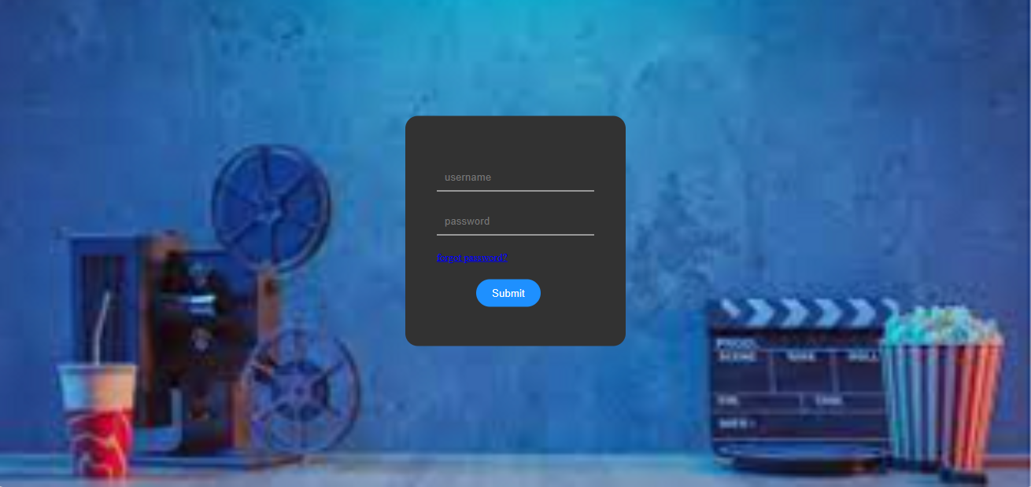

This involve the implementation of robust system that allows users to create

an accounts securely , customize their experience and ensure data privacy . This involves

multi-factor authentication with industry standards to secure access to our virtual cinema

platform and it also contains a forget password option and it also includes authentication

mechanisms. We have created the platform using html, CSS and Java .

**Code for user login :**

<html>

<head>

<tittle>VIRTUAL CINEMA LOGIN PLATFORM</tittle>

<style>

body{

margin:0;

padding:0;

background-image:url(background.jpg.png);

background-size: cover;

}

.container{

top:50%;

left:50%;

position:absolute;

transform:translate(-50%,-50%);

}

.card{

padding:60px 40px 50px 40px;

background:rgb(50,50,50);

border-radius:16px;

margin-bottom:10px;

}

#name{

width: 200px;

border:none;

background:transparent;

border-bottom:1px solid white;

padding:10px;

margin-bottom:20px;

color: white;

}

#button{

border-radius:20px;

padding:10px 20px;

background: dodgerblue;

color:white;

margin-top:20px;

border:none;

outline: none;

margin-left:50px;

}

a{

font-size: 13px;

}

</style>

</head>

<body>

<div class="container">

<div class="card">

<input type="text" placeholder="username" id="name"><br>

<input type="password" placeholder="password" id="name"><br>

<a href="#">forgot password?</a><br>

<input type="submit" value="Submit" id="button">

<body>

</html>

**HOME PAGE :**

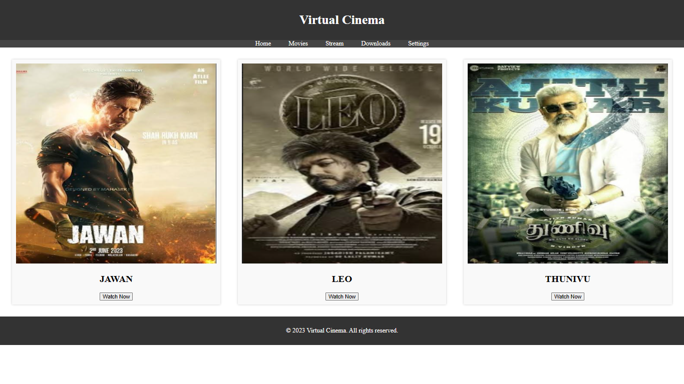

Implementation of creating an aesthetically pleasing and user-friendly interface,ensuring that

users can seamlessly navigate, discover content and enjoy an immersive cinematic experience .We

have created this platform using HTML, CSS, Javascript .

**Code for home page:**

<!DOCTYPE html>

<html>

<head>

<title>Virtual Cinema</title>

<link rel="stylesheet" type="text/css" href="styles.css">

<style>

/* Reset default margin and padding */

body, ul {

margin: 0;

padding: 0;

}

/* Style the header */

header {

background-color: #333;

color: #fff;

text-align: center;

padding: 10px 0;

}

/* Style the navigation menu */

nav ul {

background-color: #444;

list-style: none;

text-align: center;

}

nav ul li {

display: inline;

margin: 0 20px;

}

nav ul li a {

text-decoration: none;

color: #fff;

}

/* Style the movie listings */

.movie-list {

display: flex;

justify-content: space-between;

flex-wrap: wrap;

padding: 20px;

}

.movie {

width: 30%;

background-color: #f9f9f9;

padding: 10px;

margin: 10px;

box-shadow: 0 0 5px rgba(0, 0, 0, 0.2);

text-align: center;

}

.movie img {

width: 100%;

}

/* Style the user panel */

.user-panel {

background-color: #f9f9f9;

padding: 10px;

margin: 10px;

box-shadow: 0 0 5px rgba(0, 0, 0, 0.2);

}

/* Style the footer */

footer {

background-color: #333;

color: #fff;

text-align: center;

padding: 10px 0;

}

</style>

</head>

<body>

<header>

<h1>Virtual Cinema</h1>

</header>

<nav>

<ul>

<li><a href="#">Home</a></li>

<li><a href="#">Movies</a></li>

<li><a href="#">Stream</a></li>

<li><a href="#">Downloads</a></li>

<li><a href="#">Settings</a></li>

</ul>

</nav>

<section class="movie-list">

<article class="movie">

<img src="jawan poster.png" width="300" height="500" alt="jawan">

<h2>JAWAN</h2>

<button>Watch Now</button>

</article>

<article class="movie">

<img src="leo poster.png" width="300" height="500"

alt="leo">

<h2>LEO</h2>

<button>Watch Now</button>

</article>

<article class="movie">

<img src="thunivu poster.png"

width="300" height="500" alt="thunivu">

<h2>THUNIVU</h2>

<button>Watch Now</button>

</article>

<!-- Add more movie listings here -->

</section>

<footer>

<p>&copy; 2023 Virtual Cinema. All rights reserved.</p>

</footer>

</body>

</html>

**PHASE 4 : DEVELOPMENT OF PART-2**

**INTRODUCTION :**

Using IBM Cloud Foundry for media streaming

offers a reliable and scalable solution for delivering high-quality content to a wide audience. This

platform provides the necessary infrastructure and tools to host, manage, and optimize media

streaming applications, ensuring a seamless and efficient experience for users. With IBM Cloud

Foundry, you can leverage cloud-based resources and services to enhance the performance,

and accessibility of your media streaming applications, ultimately contributing to a successful and

engaging user experience.

considerations for feature engineering in this scenario: Feature engineering for media streaming in the context of IBM Cloud

involves designing and creating data features to improve the performance

and capabilities of your media streaming platform. Here are some steps and

1. **Data Collection:**

Gather data related to your media streaming service, such as user

interaction data, content metadata, and performance metrics. This data can

come from various sources, including user logs, content databases, and

streaming server logs.

1. **Data Preprocessing:**

Clean and preprocess the collected data. This may involve handling

values, removing outliers, and normalizing or scaling data as needed.

1. **Feature Selection:**

Identify relevant features that can impact your media streaming

These could include user demographics, content genres, playback quality,

and more. Consider using domain knowledge and data analysis techniques

to select the most valuable features.

1. **Feature Engineering:**

Create new features or transform existing ones to extract

valuable information. For media streaming, this could involve creating

features like user engagement scores, content popularity scores, or quality

of experience (QoE) metrics based on buffering and playback data.

1. **Incorporate Real-time Data:**

For live media streaming, consider incorporating real-time data

from streaming servers and user interactions. This can enable dynamic

feature engineering and personalization in real-time.

1. **Machine Learning Models:**

Utilize machine learning models to leverage these engineered

features. You can use models to predict user behavior, recommend content,

or optimize streaming quality. IBM Cloud offers various services for building

and deploying machine learning models, such as IBM Watson Machine

Learning.

1. **A/B Testing:**

Use A/B testing to evaluate the impact of your feature engineering

efforts. Compare the performance of your media streaming service with

and without the engineered features to measure their effectiveness.

1. **Scalability and Cost Considerations:**

Ensure that your feature engineering and machine learning solutions are scalable and

cost-effective in the cloud environment. IBM Cloud provides resources for autoscaling and cost

optimization.

1. **Monitoring and Maintenance:**

Continuously monitor the performance of your feature-models and features. Update

them as needed to adapt to changing user behaviors and streaming patterns.

1. **Data Security and Compliance**:

Ensure that you handle user data and content metadata with privacy

and compliance in mind. IBM Cloud provides tools and services to help with

data security and compliance requirement By leveraging these features and capabilities of IBM

Cloud can streamline and optimize the model training process for media streaming.

**DEVELOPING MEDIA STREAMING PLATFORM**

**PHASE :5 PROJECT DOCUMENTATION**

1 Project Summary

• Provide an overview of the project's objective and scope.

• Highlight the key elements of the platform, including features, design, and innovation.

2 Feature Description

• Describe the platform's features in detail, focusing on user registration, video upload, and

ondemand streaming.

3 User Interface and Design

• Explain the user interface design and its intended user experience.

• Include visual representations where applicable.

4 Video Upload Process

• Detail the video upload process, including any technical considerations.

• Discuss video transcoding and storage.

5 Streaming Integration and Testing

• Discuss the integration of IBM Cloud Video Streaming services.

Explain the testing process and results.

6 User Experience and Innovation

• Reflect on the importance of providing a seamless and immersive user experience.

• Discuss any innovative features incorporated in the project

**Conclusion**

In conclusion, understanding the problem statement is fundamental to project success. It

ensures that the objectives are clear, and the design thinking process sets the project on the right track.

Creating a project document that encompasses all these aspects provides a structured plan to follow.

With this roadmap in place, the journey to creating a virtual cinema platform using IBM Cloud Video

Streaming.